PS-1601-1LA PMBUS GUI (Graphical User Interface) Specification

|  |  |  |  |
| --- | --- | --- | --- |
| **Revision** | **Date** | **Author** | **Comments** |
| 0.0 | 12/July/2021 | Chen Wu Heng | Initial version |

**1. Product Overview**

1.1 Introduction....................................................................................................1

1.2 The Development System’s Components.....................................................2

**2. Installation and Operation**

2.1 Getting Started..............................................................................................13

2.1.1 Required Software.........................................................................................13   
 2.1.2 Required Hardware....................................................................................13

2.2 Graphical User Interface Installation.............................................................14   
 2.3 Driver Installation for the Adapter..................................................................20   
 2.4 PMB Software Uninstall....................................................... ...........................23

**3. Graphical User Interface Description**

3.1 Introduction..................................................................................................27

3.2 The Graphical User Interface......................................................................28   
 3.2.1 Menu Bar............................................................................................................28   
 3.2.2 Connection Bar......................................................................................................28   
 3.2.3 Status Bar...............................................................................................................29   
 3.2.4 LOG Text Box.......................................................................................................29   
 3.2.5 Clear Log Button........................................................................................29   
 3.2.6 Status Menu...............................................................................................30   
 3.2.7 Basic Settings Menu...................................................................................33   
 3.2.8 Advanced Settings Menu...........................................................................35   
 3.2.9 Statistics Menu ..........................................................................................37   
 3.2.10 Alarms Details Menu................................................................................38   
 3.2.11 About Menu..............................................................................................39

3.2.12 Help Menu.................................................................................................39   
 3.2.13 Developer Menu........................................................................................40

Contents

1. **PRODUCT OVERVIEW**
   1. INTRODUCTION

The PMBus™ Graphical User Interface (PMBus GUI) is a PMBus user interface that can be

used with any device that has a Power Management Bus (PMBus) protocol incorporated.

* 1. THE DEVELOPMENT SYSTEM’S COMPONENTS

To use the GUI, the following tools are required:

• PMBus™ Graphical User Interface:

This Graphical User Interface allows monitoring and changing input and output parameters

This windows application must include Pickits Dll v2.40 software components which

provides the Basic functions to implement the communication and control when PICkit™

Serial Analyzer is employed

• PICkit™ Serial Analyzer, Firmware Revision 0x0305 or newer

PICkit is recommended as a communication tool made by Microchip to configure the PSU

board provides a method to evaluate/demonstrate the capabilities of the PMBus™ Graphical

User Interface.

This device allows I/O control and custom device configuration. In order to connect the GUI to

The device, a PICkit Serial Analyzer or an PSU board Breakout Module must be used.

1. SYSTEM OVERVIEW

2.1 System Hardware Connection

In order to install, use and evaluate the product, there are several software and hardware tools required to be

Installed and/or set.

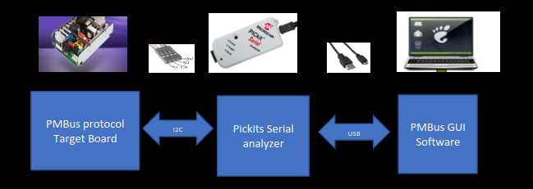

2.1.1 Required Software

• PMBus Monitoring GUI (v.x.x) including PICkits Dlls V2.40

• Microsoft® .NET Framework 4.5 or Higher

• Microsoft Windows® 7 or Higher

2.1.2 Required Hardware

2.1.2.1 CONNECTED BOARDS

• Any board that supports the PMBus protocol

• I2C Cable

2.1.2.2 COMMUNICATION TOOLS

• PICkit™ Serial Analyzer, Firmware Revision 0x0305 or newer

• USB Cable

1. **THE GRAPHICAL USER INTERFACE**

3.1 THE GRAPHICAL USER INTERFACE

The following sections describe the items in the Graphical User Interface.

3.1.1 PMBus software name, logo and version

It locates left-top side in GUI Software interface.



3.1.2 Device Setting

There is two baud rate options of I2C bus in this setting as the below table

|  |  |
| --- | --- |
| **Baud Rate Configuration** | Description |
| *100Khz* | I2C Bus runs with *100Khz* |
| *400Khz* | I2C Bus runs with 400Khz |

3.1.3 Device Execute

There are two connection control selection with target Board in this setting.

|  |  |
| --- | --- |
| **Option** | Description |
| *Connect* | Manually connect PICkit serial Analyzer |
| Disconnect | Manually disconnect PICkit serial Analyzer |

3.1.4 General Setting

There are 3 items configuration in this Setting.

*•* This drop-down menu *Target Board’s device address setting,*

*(* PMBus™ protocol device*).* The connector is automatically recognized.

Connect the Target board to the PC BY connecting a PICkit™ Serial Analyzer.

*• Interval timing setting: for monitoring time interval setting. Unit: ms*

*• Enable PEC and Disable PEC setting*

3.1.5 Application Log

Application Log is not input window. It displays the below information during its running.

3.1.5.1 *Error information during Reading, writing, control*

*• Connection Status, either Wrong or Correct*

*• Wrong PEC Status*

3.1.5.2 *Result information during Reading, writing, control*

*• Reading Result Message* except FRU EEPROM

*• Writing Result Message*

3.1.5.3 Instruction Message

*• Reminder* *to select an index if missed*

*• Reminder Next step instruction during sequence procedure such as calibration*

3.1.5.4 Connection Bar

The connection bar contains the items in Table 3-2.

FIGURE 3-3: Connection Bar.

|  |  |
| --- | --- |
| **Status** | Description |
| Connected | Displays Message “Pickits serial Analyzer connected” in green color |
| Disconnected | Displays message “Hardware Not Detected” in Red color |

It locates in left-down corner.

**3.2 Tag Items**

The menu bar contains the items available for the user to display the device’s characteristics and settings, as shown in Table 3-1.

3.2.1 Application Tag Summary

|  |  |
| --- | --- |
| **Tags** | Description |
| Read | Displays the most common items. Once or Polling |
| MFR | Displays the MFR Setting including Vin, Iin, Vout, Iout, Pout and ambient Temperature |
| Constant Data | Displays the Target board’s parameter limitation for both fault and warning |
| Status | Displays and Set the Status. |
| Control | Some Special control Command such as PSU remote On/off |
| Calibration | Calibration procedure interface, which will follow Liteon Calibration document |
| Event Log | Event Log display latest event History |
| FRU EEPROM | External serial eeprom programming and monitoring interface |
| Statistics | (Optional) Displays the Statistics menu. |
| Alarms Details | Displays the Alarms Details menu. |
| About | Shows information about the version of the product. |
| Help | Opens a document with details on the PMBus™ Monitoring Graphical User Interface. |

3.2.2 Connection Bar

The connection bar contains the items in Table 3-2.

FIGURE 3-3: Connection Bar.

|  |  |
| --- | --- |
| **Status** | Description |
| Connected | Displays Message “Pickits serial Analyzer connected” in green color |
| Disconnected | Displays message “Hardware Not Detected” in Red color |

It locates in left-down corner.

3.2.3 Description for Tags

3.2.3.1 Read Tag:

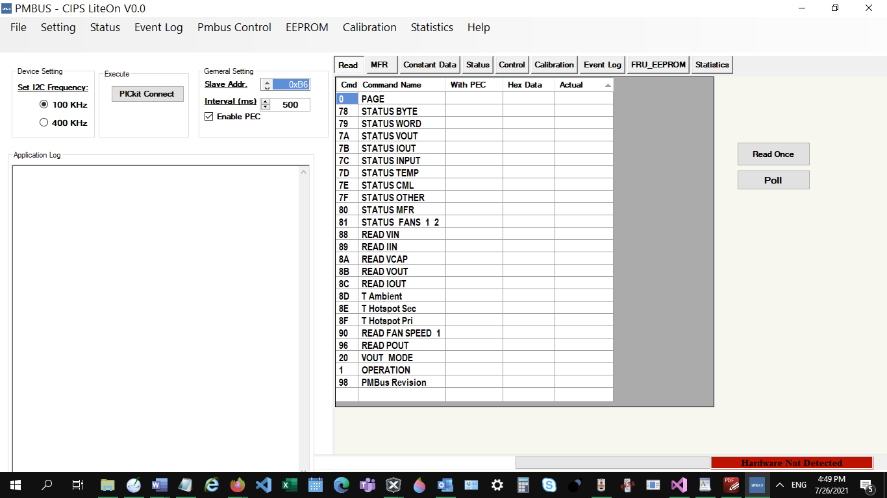

|  |  |
| --- | --- |
| **Function** | Description |
| Read Once | One time reading |
| Poll | Continuously Reading, time interval is in “General Setting” |

3.2.3.2 MFR Tag:

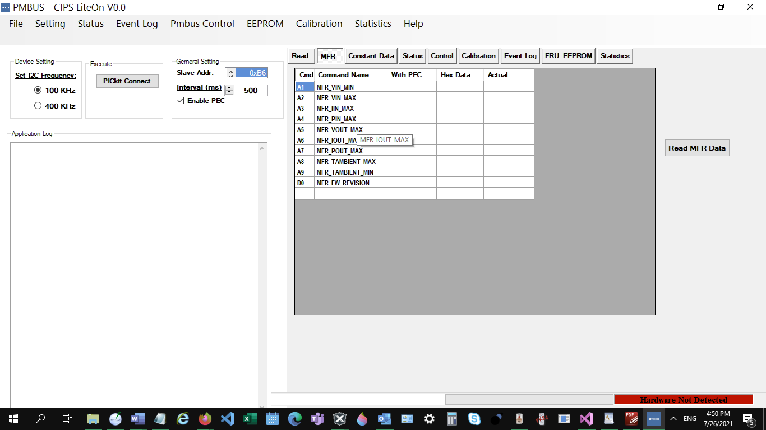

“Read MFR Data” is one time reading button.

3.2.3.3 Constant Tag:

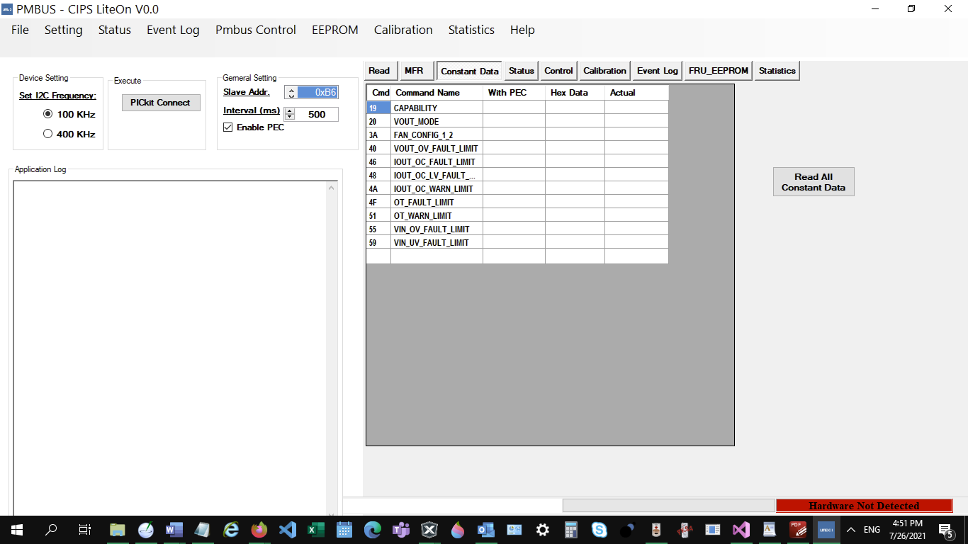

“Read All Constant Data” is one time reading button for fault and warning value retrieve.

3.2.3.4 Status Tag:

|  |  |  |
| --- | --- | --- |
| Panel Display | Item | Description |
| STATUS | STATUS byte | Shows the summary of whole status ( LSB). **Busy** - busy and unable to respond; **OFF -** not providing to the output; **VOUT_OU -** fault occured**; IOUT_OU** - fault occured; **VIN_UV** - fault occured; **TEMPERATURE**-fault/warning occurred;**CML**-Communication,memory or logic fault occurred;None of the above Green indicates relevat error no occurred; Red color indicates error have occurred |
|  | STATUS Word | Shows the summary of whole status (MSB). **VOUT** - fault/warning occured; **IOUT** - fault/warning occured;t; **INPUT** - Vin,Iin,Pin fault/warning occured; **MFR** - manufactirer specfic fault or warning occured; **POWER GOOD#** - Negated if present; **FANS**- A fan or airflow fault/warning occurred;**OTHER**-Other_Bit set Green indicates relevat error no occurred; Red color indicates error have occurred |
|  | STATUS VOUT | The green alarm on the left will turn red when the VOUT value is lower than or equal to the output undervoltage warning/Fault limit.  The output undervoltage warning limit is greater than the output undervoltage Fault limit. If the VOUT value is lower than or equal to the output undervoltage warning/Fault limit, the red alarm turns on and stays on until the “CLEAR FAULTS” command is sent |
|  | STATUS IOUT | The green alarm on the left will turn red when the IOUT value is lower than or equal to the output undervoltage warning/Fault limit.  The output undervoltage warning limit is greater than the output undervoltage Fault limit. If the IOUT value is lower than or equal to the output undervoltage warning/Fault limit, the red alarm turns on and stays on until the “CLEAR FAULTS” command is sent |
|  | STATUS INPUT | Shows the input undervoltage,VIN OVW,VIN UVF Fault limit. The green alarm on the left will turn red when the VIN value is lower than or equal to the  input undervoltage,VIN OVW,VIN UVF warning/Fault limit. The input undervoltage warning limit is greater than the input undervoltage Fault limit. If the  VIN value is lower than or equal to the input undervoltage warning/Fault limit, the red alarm turns on and stays on until the “CLEAR FAULTS” command is sent from the Alarms Details menu. |
|  | STATUS TEMPERATURE | Shows the TEMPERATURE OTP, OTW limit. The green alarm on the left will turn red when the TEMPERATURE value is more than or equal to the TEMPERATURE warning/Fault limit.  The TEMPERATURE OTW warning limit is lower than the TEMPERATURE OTP Fault limit.  If the TEMPERATURE value is more than or equal to the TEMPERATURE warning/Fault limit, the red alarm turns on and stays on until the “CLEAR FAULTS” command is sent from the Alarms Details menu. |
|  | STATUS FAN 1-2 | Shows the position 1 FAN, FAN F1 FAIL,F1 OVR(FAN 1 Speed Overridden), which condition to ne set the response this condition are defined by eah device manufacturer. The green alarm on the left will turn red when the F1 FAIL,F1 OVR condition to reach. the red alarm turns on and stays on until the “CLEAR FAULTS” command is sent from the Alarms Details menu. If the condition of FAN F1 FAIL,F1 OVR(FAN 1 Speed Overridden) is gone. and back to normal working status ,the color becomes green. |
|  | STATUS CML | Shows the 4 errors , InvalidCmd,Invalid Data,InvalidPec and Processor Fault Green color indicate no error for the bit. Red color indicates error rise. |
|  | STATUS OTHER | Shows Output OR-ing Device fault limit. The green alarm on the left will turn red when the VIN value is lower than or equal to the Output OR-ing voltage warning/Fault limit.  If the Output OR-ing voltage value is more than or equal to the Output OR-ing voltage warning/Fault limit, the red alarm turns on and stays on until the “CLEAR FAULTS” command is sent from the Alarms Details menu. |
|  | STATUS MFR | Shows manufacturer defined fault limit. |

|  |  |
| --- | --- |
| **Status Operation** | Description |
| Read | Status by index selection |
| Write | Write index Status with data input box |
| Data | Data input box |
| Status Index | Down-up item to select index of Status |
| Page Index | Down-up item to select index of Page. Default 0 |

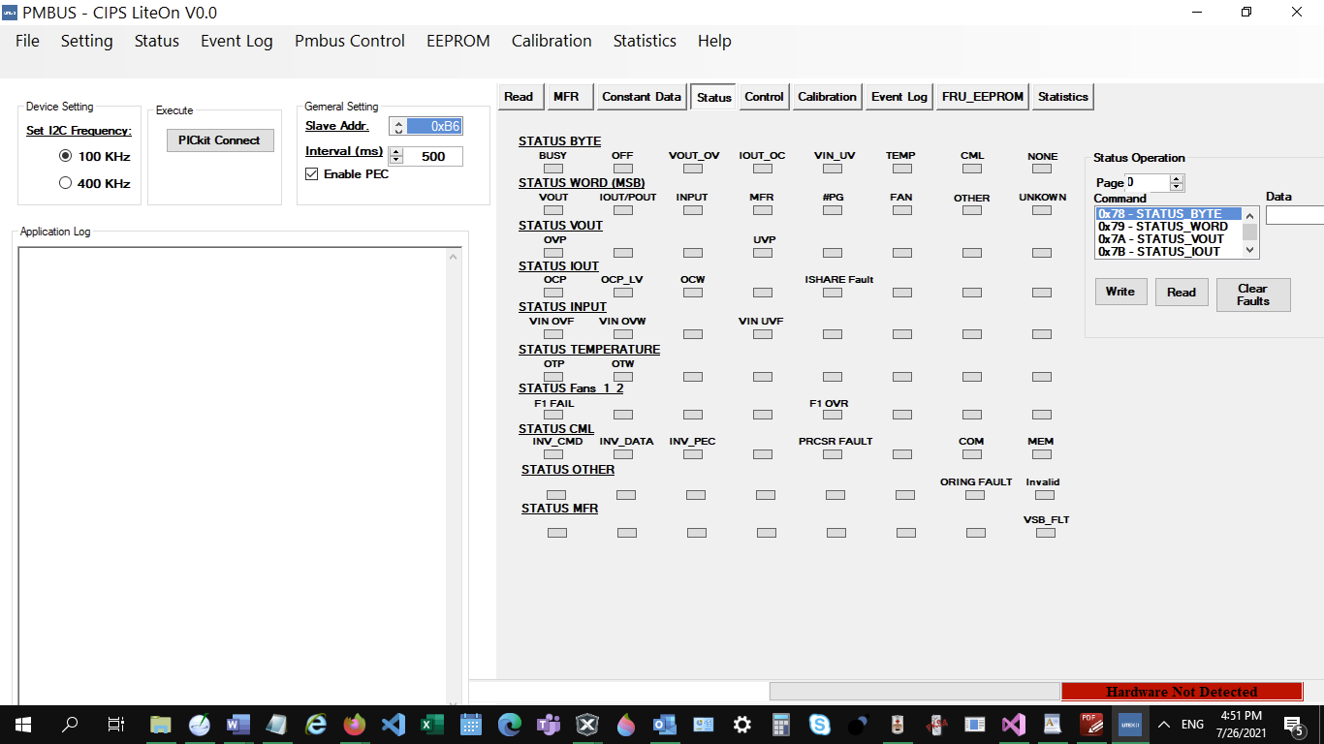

3.2.3.5 Control Tag

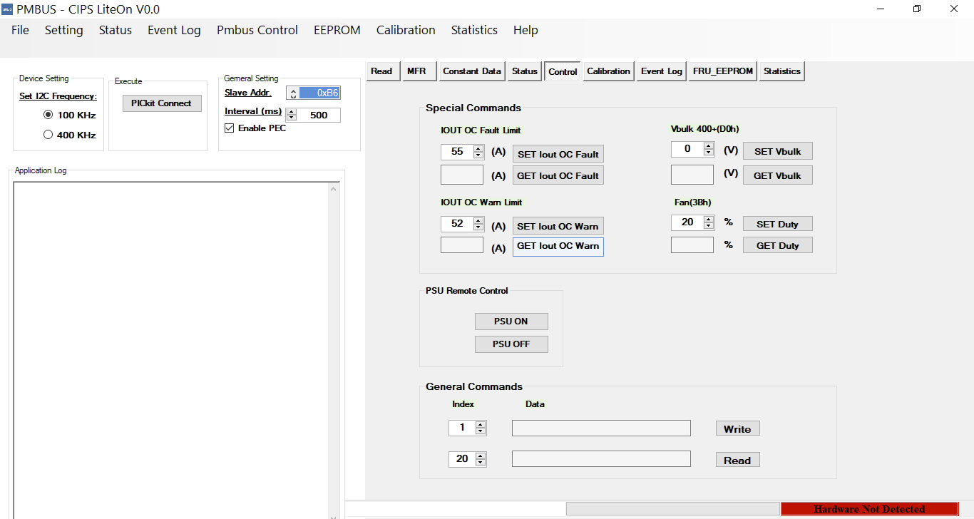

|  |  |
| --- | --- |
| **Status Operation** | Description |
| SET IOUT OC Fault | Status by index selection |
| GET IOUT OC Fault | Write index Status with data input box |
| SET IOUT OC Warning | Data input box |
| GET IOUT OC Warning | Down-up item to select index of Status |
| SET Duty | % Percentage |
| GET Duty | % Percentage |
| PSU ON | Remote enable PSU output |
| PSU OFF | Remote disable PSU output |

3.2.3.6 Calibration Tag:

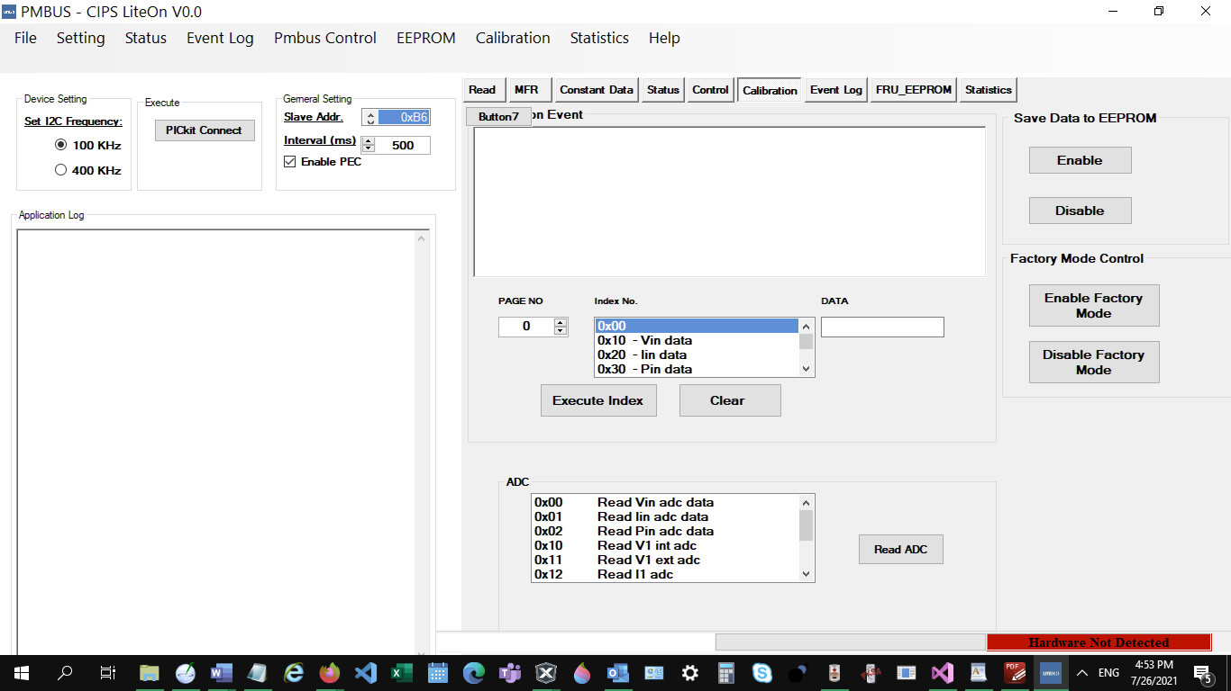

?

3.2.3.7 Event Log Tag

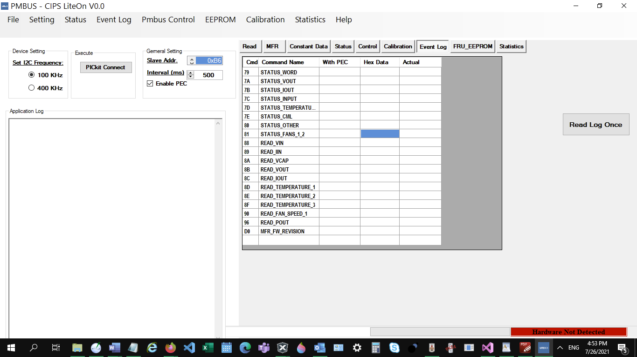

|  |  |
| --- | --- |
| **Status Operation** | Description |
| Read Log Once | Display 5 latest event in Application Log and the latest in Grid view |

3.2.3.8 MFR EEPROM Tag

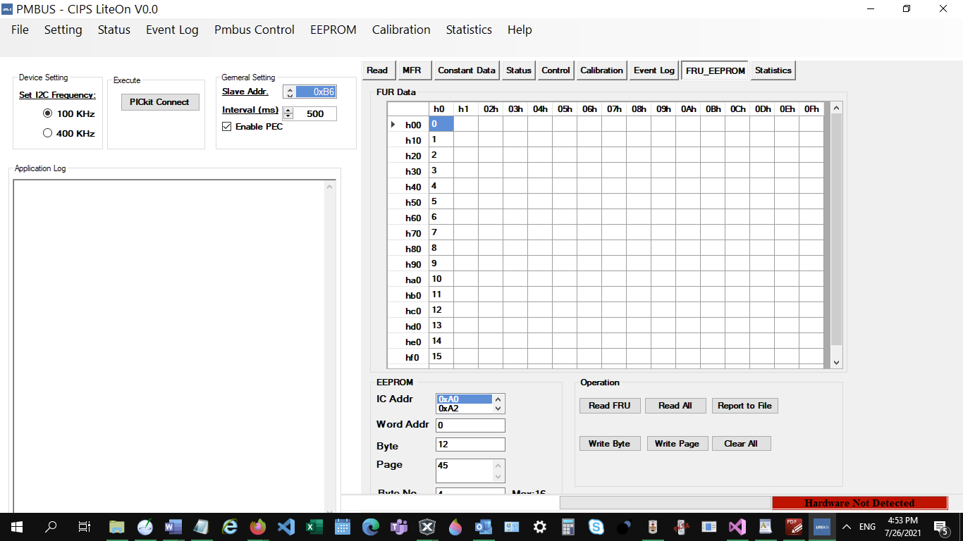

|  |  |
| --- | --- |
| **Status Operation** | Description |
| Read FRU | Status by index selection |
| Read All | Write index Status with data input box |
| Write FRU | Data input box |
| Write Byte | Down-up item to select index of Status |
| Write Page | % Percentage |
| Report To File | Report current eeprom data to a file |
| Clear All | Clear all eeprom data to 0 |

Statistics Tag:

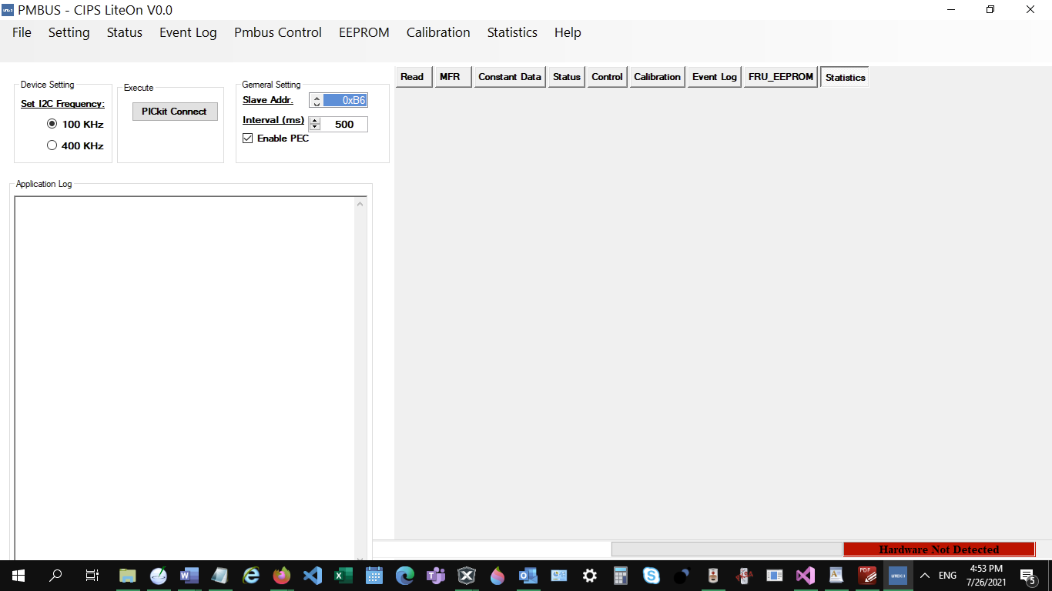

Optional?

End